# Q1 to Q12 have only one correct answer. Choose the correct option to answer your question.

1. Which of the following is an application of clustering?

All of the above

1. On which data type, we cannot perform cluster analysis?

None

1. Netflix’s movie recommendation system uses-

Reignforcement learning

1. The final output of Hierarchical clustering is-

A map defining the similar data points into individual groups

1. Which of the step is not required for K-means clustering?

None

1. Which is the following is wrong?

k-nearest neighbour is same as k-means

1. Which of the following metrics, do we have for finding dissimilarity between two clusters in hierarchical clustering?
2. Single-link
3. Complete-link
4. Average-link Options:

1, 2 and 3

1. Which of the following are true?
2. Clustering analysis is negatively affected by multicollinearity of features
3. Clustering analysis is negatively affected by heteroscedasticity Options:
   1. 1 only
4. 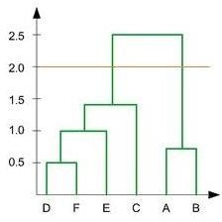In the figure above, if you draw a horizontal line on y-axis for y=2. What will be the number of clusters formed?

2

1. For which of the following tasks might clustering be a suitable approach?

Given sales data from a large number of products in a supermarket, estimate future sales for each of these products.

1. Given, six points with the following attributes:

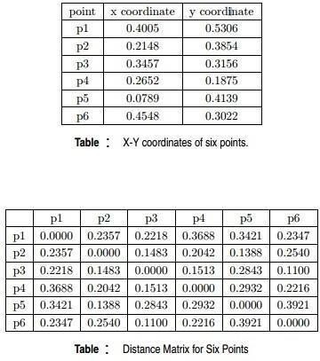

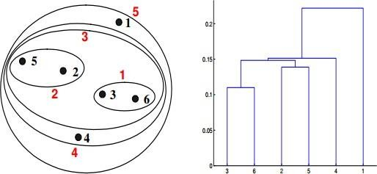Which of the following clustering representations and dendrogram depicts the use of MIN or Single link proximity function in hierarchical clustering:

a.



1. Given, six points with the following attributes:



Which of the following clustering representations and dendrogram depicts the use of MAX or Complete link proximity function in hierarchical clustering.



b. 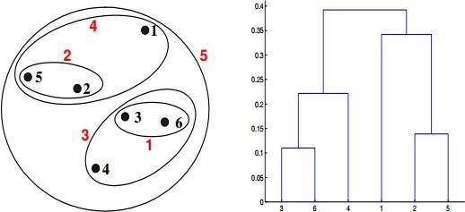

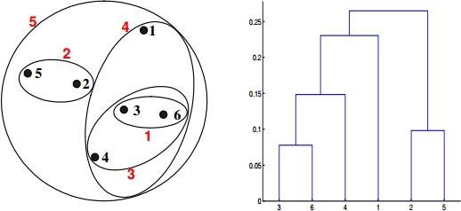

d.

# Q13 to Q14 are subjective answers type questions, Answers them in their own words briefly

1. What is the importance of clustering?

Clustering is important for data Mining ,It is the task of grouping a set of objects so that objects in the same group are more similar to each other than to those in other groups .it is used to find hidden relations.

1. How can I improve my clustering performance?

Graph-based clustering performance can easily be improved by applying ICA blind source separation during the graph Laplacian embedding step. Applying unsupervised feature learning to input data using either RICA or SFT, improves clustering performance